**Clustering:**

Unlike in classification & regression where we were given data points, along with output, In clustering we are only provided data points and no output or y_i’s.

The main task here is to group or cluster the **similar** data points, here similar is very very problem specific.

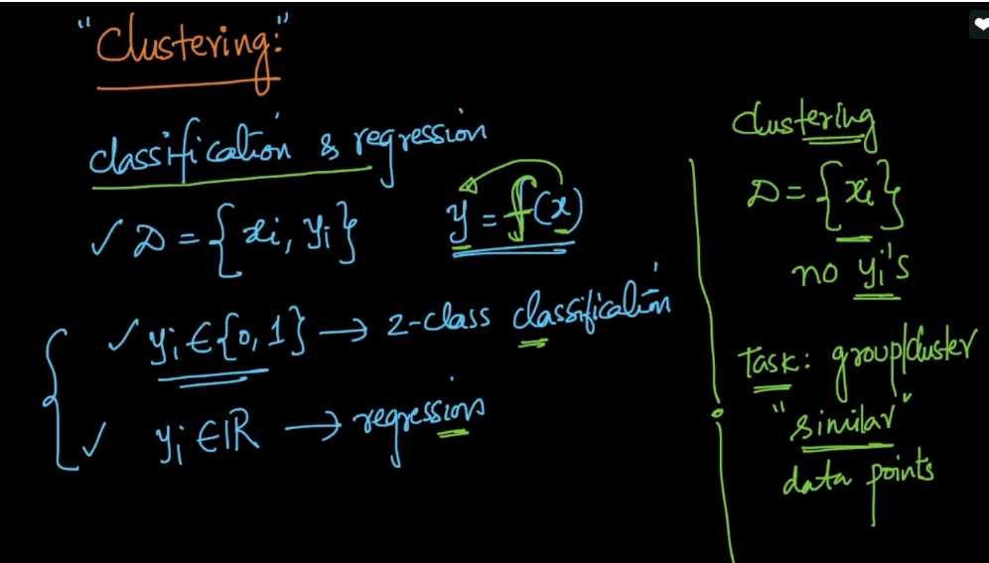

Let’s see and intuition of clustering, in below image we can see there are 3 clusters.

So what is our approach to cluster them?

Put all the points that are close in a cluster, and points that are far away in different cluster.

This is the one intuition for clustering, there can be others too.

**Commonly used algorithms in clustering:**

1. **K-means**
2. **Heriarichal**
3. **DB-scan.**

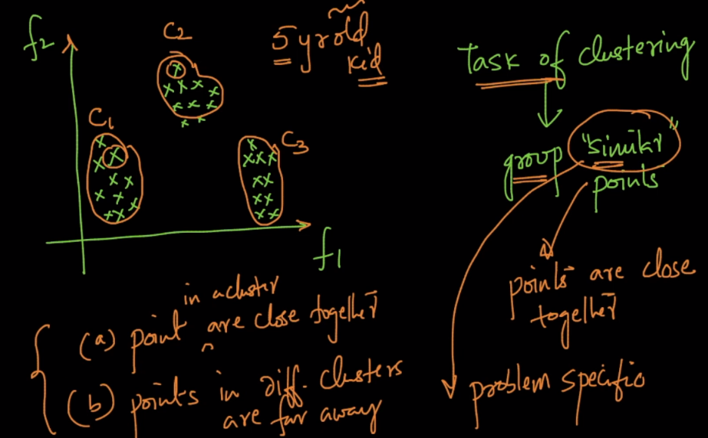

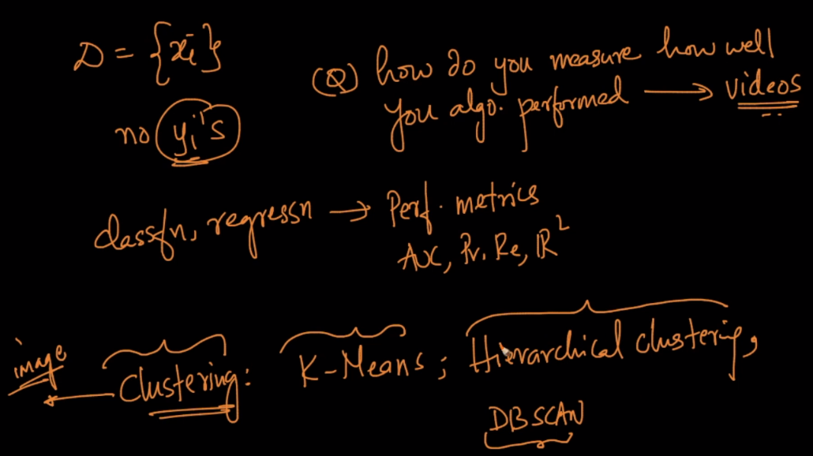

https://www.analyticsvidhya.com/blog/2015/12/10-machine-learning-algorithms-explained-army-soldier/